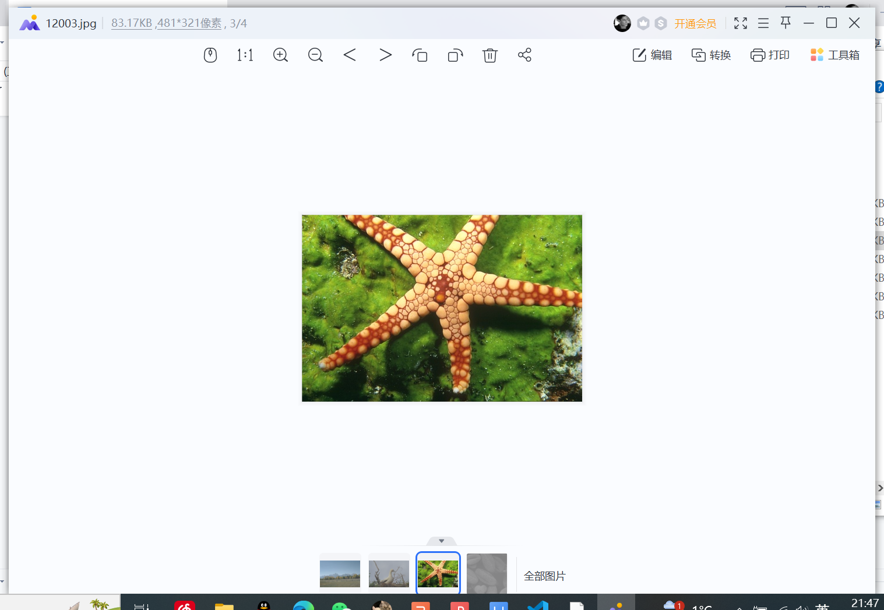import cv2

import numpy as np

# 加载图像

image = cv2.imread('12003.jpg')

# 转换为灰度图像

gray = cv2.cvtColor(image, cv2.COLOR_BGR2GRAY)

# 进行预处理

blurred = cv2.GaussianBlur(gray, (5, 5), 0)

# 边缘检测

edges = cv2.Canny(blurred, 50, 150)

# 形态学操作

dilated = cv2.dilate(edges, None, iterations=2)

eroded = cv2.erode(dilated, None, iterations=1)

# 轮廓检测

contours, hierarchy = cv2.findContours(eroded.copy(), cv2.RETR_EXTERNAL, cv2.CHAIN_APPROX_SIMPLE)

# 绘制轮廓

cv2.drawContours(image, contours, -1, (0, 255, 0), 2)

# 显示结果

cv2.imshow("Contours", image)

cv2.waitKey(0)

cv2.destroyAllWindows()

